

**Faculty of engineering - Shoubra**

**Benha University**

**Research Article / Research Project / Literature Review**

in fulfillment of the requirements of

|  |  |
| --- | --- |
| **Department** | **Engineering mathematics and physics** |
| **Division** |  |
| **Academic Year** | **2019-2020 preparatory** |
| **Course name** | **computer** |
| **Course code** | **ECE001** |

**Title: -**

**Building a website about covid19**

By:

|  |  |  |  |
| --- | --- | --- | --- |
|  | Name | Edu mail | B.N |
| 1 | Marina zarif | marina190028@feng.edu.bu.eg | 623 |

**Approved by:**

|  |  |
| --- | --- |
| Examiners committee | Signature |
|  |  |
|  |  |
|  |  |
|  |  |
|  |  |

**Research objectives**

-A brief about covid19

-An introduction to clarify the emerging corona virus

-Parts of the created website pages and their corresponding source codes

-Links to the Github repository containing the source code & the website

**Abstract**

What are corona viruses? Corona viruses are a large family of various viruses that cause many diseases that range from very simple, such as cold to other, more serious, such as the Middle East respiratory syndrome and severe acute respiratory syndrome

This type of virus causes infectious diseases that are transmitted between humans and animals, as well as from the infected person to the healthy one.

It also prepares daily statistics from the World Health Organization to know the number of new patients

**Table of contents**

Divide your research into sections or subjects, mention each section first page at this table

|  |  |
| --- | --- |
| **Subject / section** | **Page** |
| **Research objectives** | **2** |
| **Abstract** | **3** |
| **Introduction** | **5** |
| **Literature Review** | **6,7,8,9,10** |
| **Links** | **11** |
|  |  |

**Introduction**

What is Corona virus?

Corona viruses are a wide range of viruses that may cause disease in animals and humans. It is known that corona viruses cause in humans respiratory diseases that range from common colds to more severe diseases such as Middle East Respiratory Syndrome (MERS) and severe acute respiratory syndrome (SARS). The newly discovered Corona virus causes Covid-19 disease.

Covid-19 disease is an infectious disease caused by the last detected virus of the Coronavirus. There was no knowledge of the existence and disease of this new virus before its outbreak in Wuhan, China, in December 2019. Covid-19 has now become a pandemic to many countries in the world

Corona virus is a coronavirus that was first detected in Wuhan, China and it is a new virus that has not been previously identified in humans. This virus infects thousands of people daily in all parts of the world and the United States of America is the most affected by the Corona virus

The World Health Organisation (WHO) has declared the coronavirus disease 2019 (COVID-19) a pandemic[1]. A global coordinated effort is needed to stop the further spread of the virus. A pandemic is defined as “occurring over a wide geographic area and affecting an exceptionally high proportion of the population.”[2] The last pandemic reported in the world was the H1N1 flu pandemic in 2009.

**Literature Review**

screen shots :

1- main page it linked all pages with them :

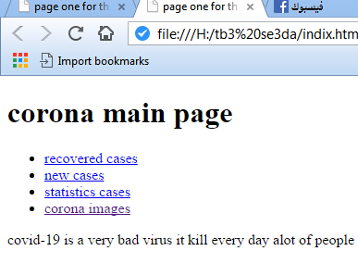

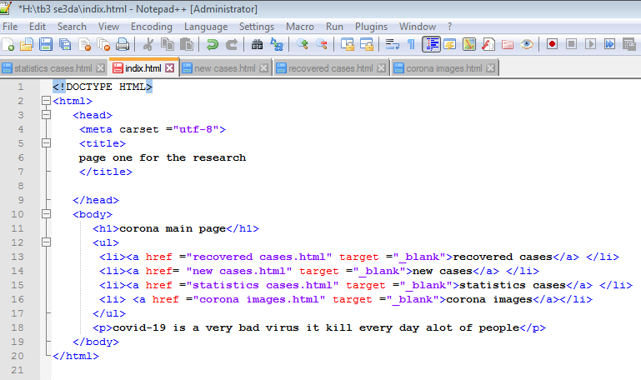

2-the number of recovered cases :

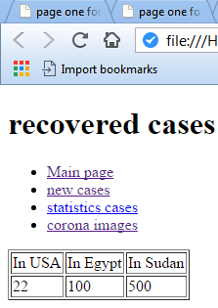

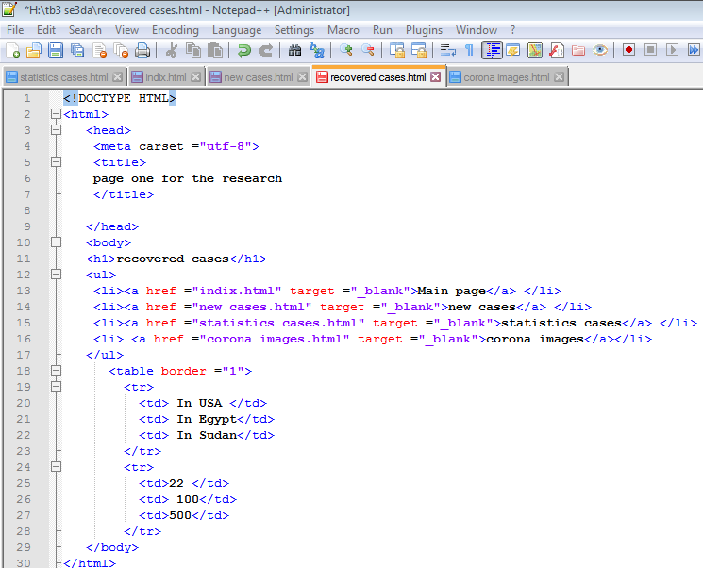

3-corona curves in countries in the pictures bellow :

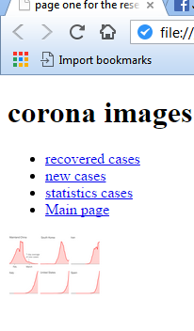

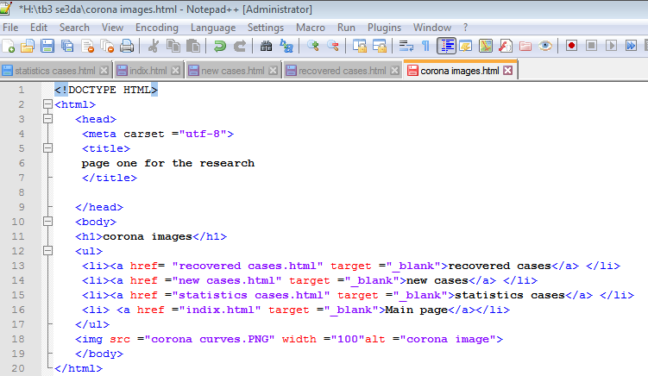

4-corona statistics cases in countries in the bellow:

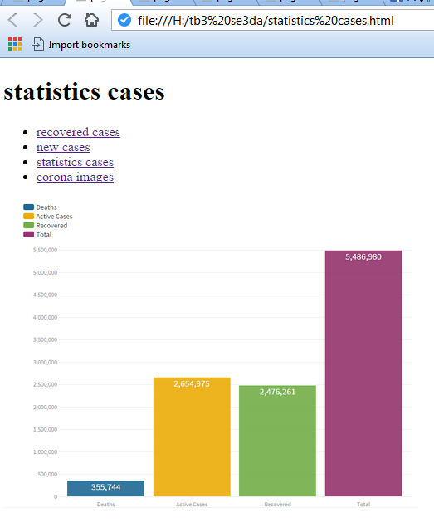

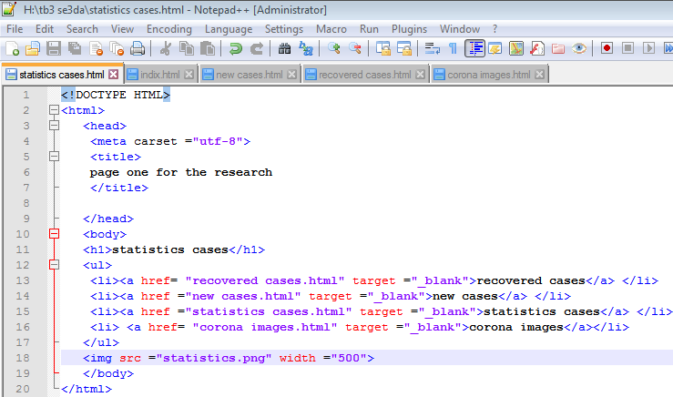

5-corona's recovered cases :





**Links**

-Github link:

**Layout and formatting**

**(Guide, don’t include this page in your research)**

Use this template

**Paper:** A4

**Margins:** 2.5 cm all from top and bottom

**1.**9 cm from left and right

**Line spacing:** 1.5

**Font:** Time New Roman

**Font size:** 14 (Except headings)

**No of pages:**Between 5 and 10 pages (Not including cover)